The octagon (Geogebra)

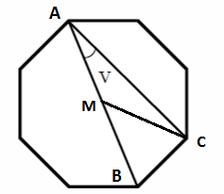
The figure shows a regular octagon with the section length 1 l.u. and the center M.
- Create the octagon in Geogebra

- What is the sum of all angles in the octagon?

- Can you determine the sum of angles in other regular polygons? Try different polygons in Geogebra. Do you discover any pattern?

- Can a polygon have as many corners you want? Any conclusion?

- Determine the angle V.

- Use Geogebra to investigate what will happen with the angle V if you move the point A to another corner in the polygon.

- Determine the angle BMC

- Investigate how it will look like in other polygons. The angle V? The angle BMC?

- How would it look like in a circel?

